CDACL-002 - Customer Segmentation
Understanding Customer Behavior and Purchase Patterns
PRABU R
Datamites Internship
19 June 2026

Introduction

Customer Segmentation Analysis helps businesses understand customer purchasing behavior and identify valuable customer groups.
The project aims to analyze customer shopping patterns using purchase data from 3900 customers and generate actionable business insights.

Problem Statement

Businesses often struggle to identify valuable customers and understand purchasing behavior. Without customer segmentation, marketing campaigns may not effectively target the right audience.
The objectives are:
- Identify product categories requiring discounts.
- Analyze spending behavior across age groups.
- Study impact of seasons and locations.
- Segment customers into groups.
- Recommend marketing strategies.

Dataset Description
The dataset contains customer purchase information collected from a retail business.
Dataset Features
- Customer_ID
- Age
- Gender
- Category
- Purchase Amount
- Location
- Season
- Payment Method
- Subscription Status
- Review Rating
- Frequency of Purchases
Total Records
- Total Customers: 3900

Data Preprocessing
1. Missing Value Check
The dataset was checked for missing values.
No significant missing values were identified.
2. Data Cleaning
- Verified data consistency.
- Checked for duplicate records.
- Ensured correct data types.
3. Age Group Creation
A new Age Group column was created for better analysis.
Age Groups
- 18–25
- 26–35
- 36–45
- 46–55
- 56+
This grouping helped analyze purchasing behavior across different age categories.
Dashboard Development
The dashboard was developed in Power BI.
KPI Cards
The following key performance indicators were created:
- Total Customers
- Average Purchase Amount
- Total Revenue
- Subscribed Customers
Visualizations:
- Segment Distribution
- Category Analysis
- Top Purchased Products
- Gender Analysis
- Subscription Analysis
- Age Group Analysis
- Season Analysis
- Location Analysis
- Payment Method Analysis

Analysis and Findings
Customer Segments
- Low Value = 38.82%
- Medium Value = 36.10%
- High Value = 25.08%
Category Performance
- Clothing = 104K
- Accessories = 74K
- Footwear = 36K
- Outerwear = 19K
Age Analysis
Spending patterns remain relatively consistent across all age groups.
Season Analysis
- Fall generated highest revenue.
- Summer generated lowest revenue.
Location Analysis
Top-performing locations include Montana, Illinois, California and Idaho.
Subscription Analysis
Only 27% customers are subscribed.
Customer Segmentation Dashboard

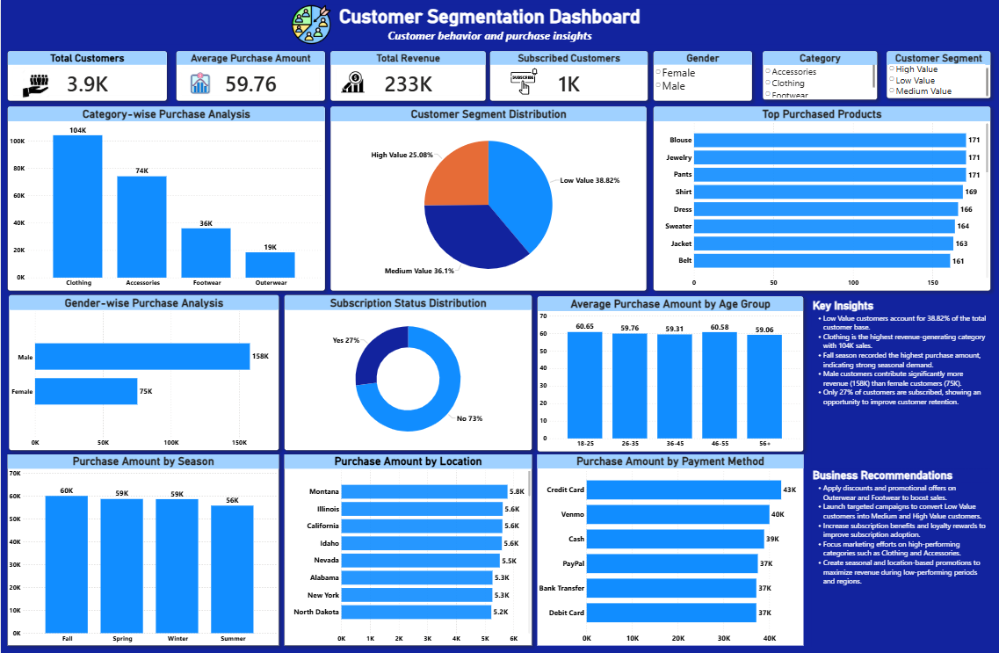

Customer Segmentation Dashboard Developed in Power Bi
The dashboard was developed using Power BI to visualize customer behavior and purchasing patterns. It includes KPI cards, customer segment distribution, category-wise revenue analysis, subscription status, age-group analysis, and business recommendations for decision-making.
Key Business Insights

- High Value customers contribute significantly to business revenue despite being only 25% of customers.
- Low Value customers account for the largest customer segment (38.82%).
- Clothing generates the highest revenue among all categories.
- Male customers contribute more revenue than female customers.
- Only 27% of customers have active subscriptions.
- Accessories represent the second-highest revenue-generating category.
- Customer segmentation helps identify high-value customers for targeted marketing campaigns.

Business Recommendations

- Apply discounts on Outerwear and Footwear products.
- Focus promotions during summer season.
- Expand marketing efforts in Montana, Illinois and California.
- Convert Low Value customers through personalized offers.
- Reward High Value customers with loyalty programs.
- Increase subscription adoption through exclusive benefits.
- Promote Clothing and Accessories through bundled offers.
- Create age-based marketing campaigns for younger customers.

Conclusion

The Customer Segmentation Analysis was conducted using 3,900 customer records to understand customer purchasing behavior, spending patterns, and shopping preferences.
The analysis identified three customer segments: High Value, Medium Value, and Low Value customers. Clothing emerged as the highest revenue-generating category, while Outerwear showed the lowest revenue and offers opportunities for promotional discounts. Seasonal analysis revealed that Fall generated the highest sales, whereas Summer recorded the lowest sales. Location analysis highlighted Montana, Illinois, and California as high-performing regions. Subscription adoption remains low, with only 27% of customers subscribed.
Overall, customer segmentation provides valuable insights that help businesses improve customer retention, increase revenue, optimize marketing strategies, and make data-driven decisions.

Business Impact

This project helps businesses:
- Identify high-value customers for loyalty and retention programs.
- Recognize low-value customers and target them with personalized offers.
- Determine which product categories require discounts and promotions.
- Understand seasonal purchasing trends for better inventory planning.
- Analyze location-wise sales performance to improve regional marketing.
- Improve subscription adoption through targeted campaigns.
- Support data-driven decision-making using customer behavior insights.
The dashboard enables management to quickly monitor customer trends and take strategic actions to maximize business performance.

Future Scope
This project can be further enhanced by:
- Implementing machine learning-based customer segmentation models.
- Predicting customer purchase behavior and future spending patterns.
- Developing personalized recommendation systems for products.
- Building customer lifetime value (CLV) prediction models.
- Performing churn prediction to identify customers likely to leave.
- Integrating real-time customer transaction data for continuous monitoring.
- Creating automated marketing campaigns based on customer segments.
- Expanding analysis with advanced demographic and behavioral attributes.
These enhancements can provide deeper business insights and further improve customer engagement, retention, and profitability.

